**Blue Blog Platform Documentation**

**Introduction**

Blue Blog is a collaborative platform designed for individuals to create accounts, write, publish, and delete blog posts, as well as search, view, and comment on others' blogs.

**Platform Structure**

The Blue Blog platform consists of seven main pages:

**1.Home (Index):**

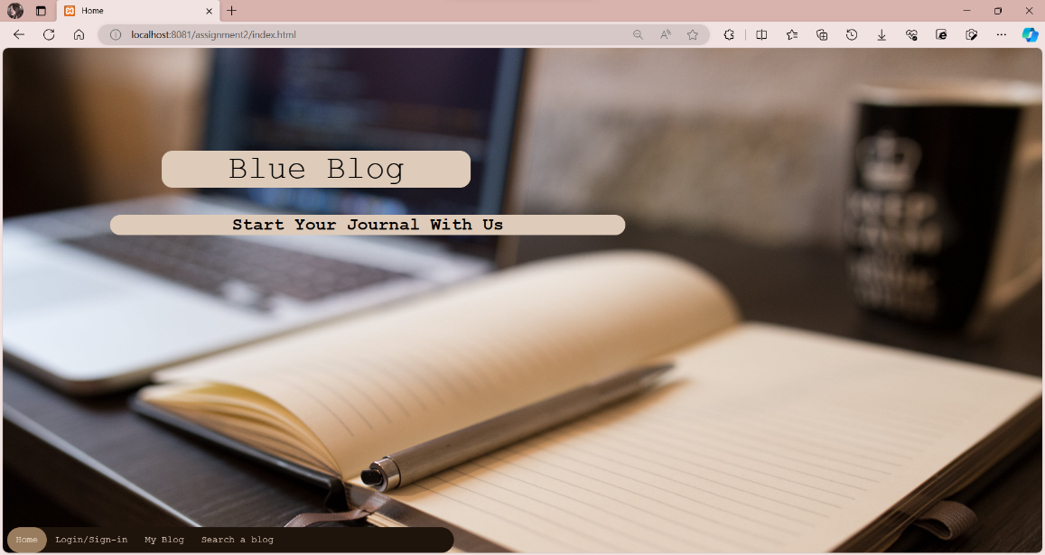The landing page providing an overview of the platform.

**2.Sign Up & Log In:**

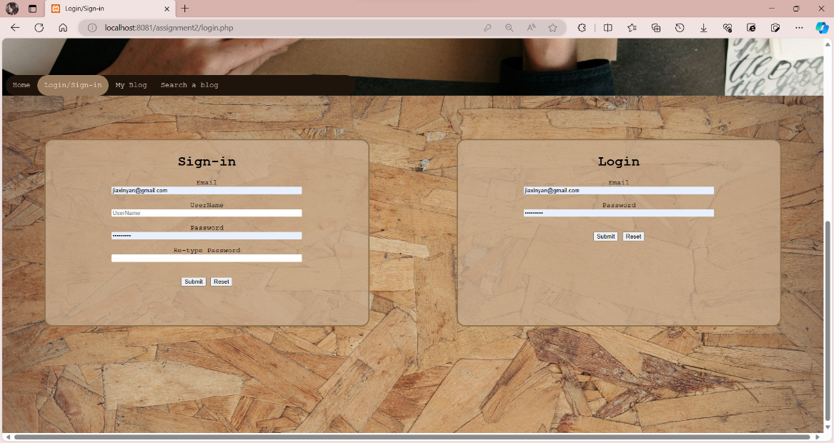Users can create new accounts or log in to existing ones.

**3.My Blog:**

The user's personalized main page where they can view their published blog posts.

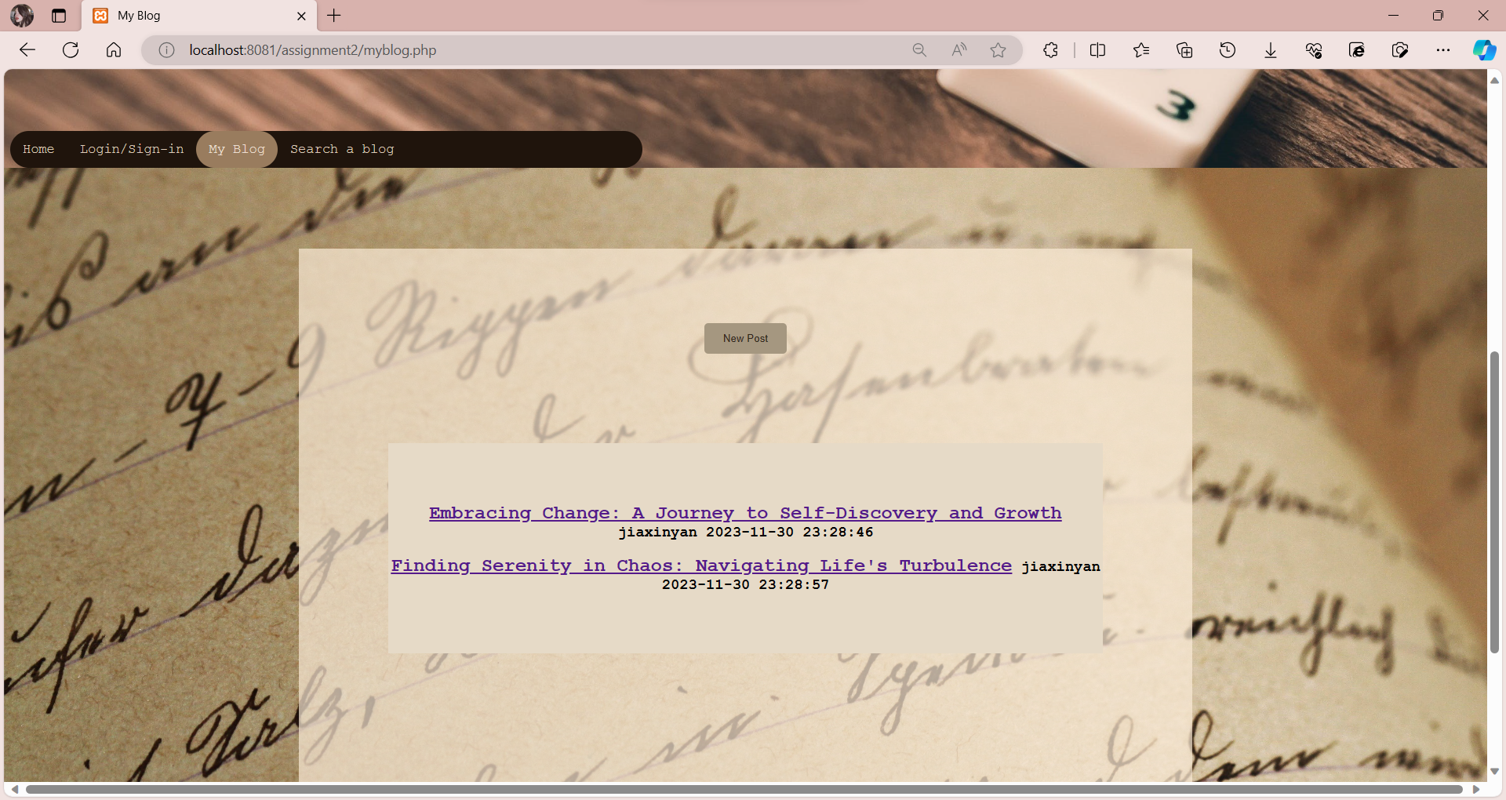

**4.New Post:**

The page dedicated to writing and publishing new blog posts.

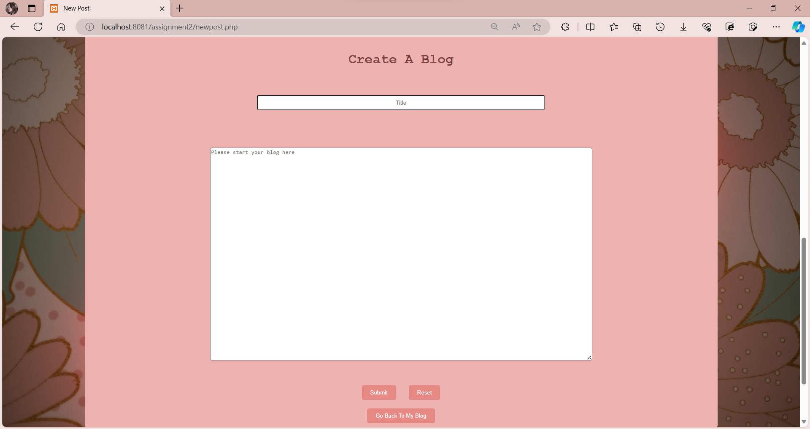

**5.Search:**

A page designed for searching other users' blog posts.

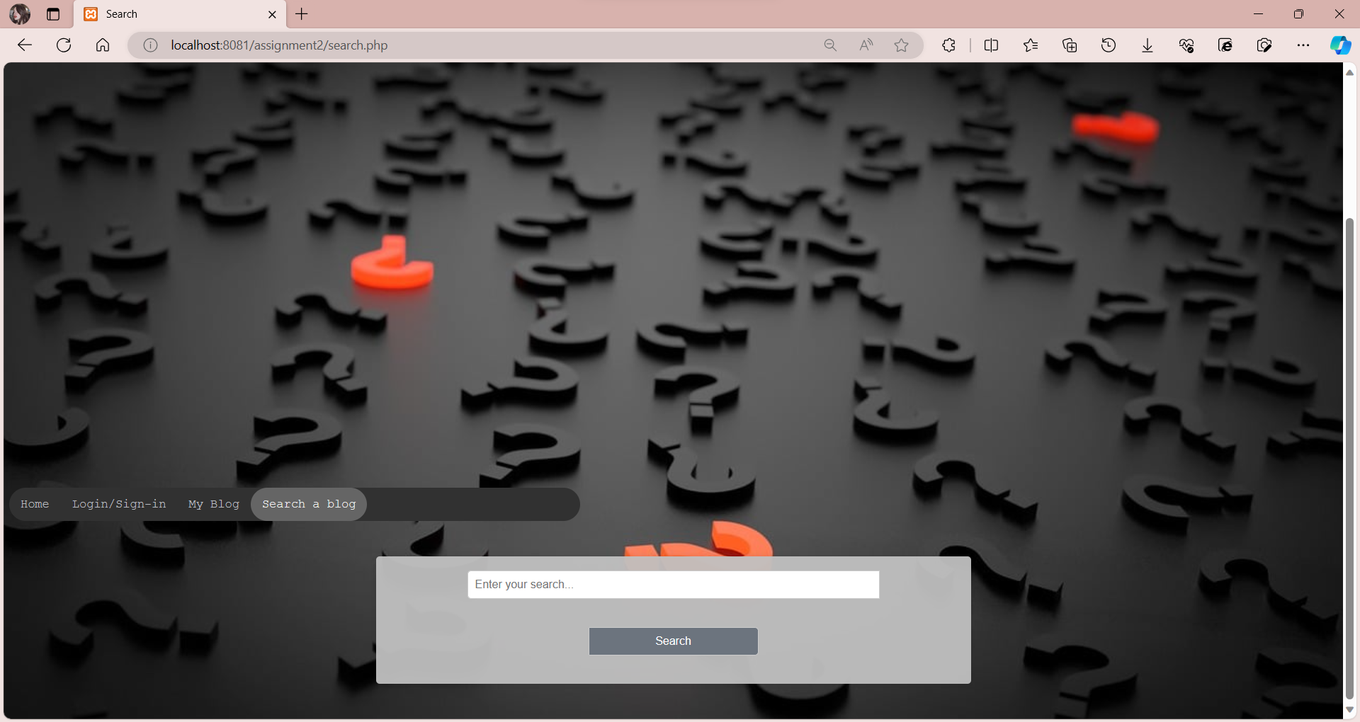

**6.Search Results:**

The results page displaying relevant blog posts based on user searches.

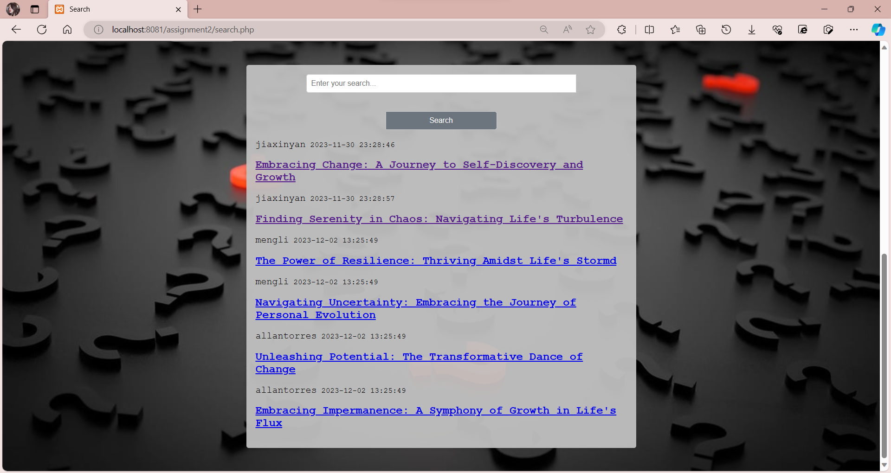

**7.Blog Content:**

Accessible through "My Blog" and "Search Results," this page allows users to view the detailed content of a blog post and submit their own comments.

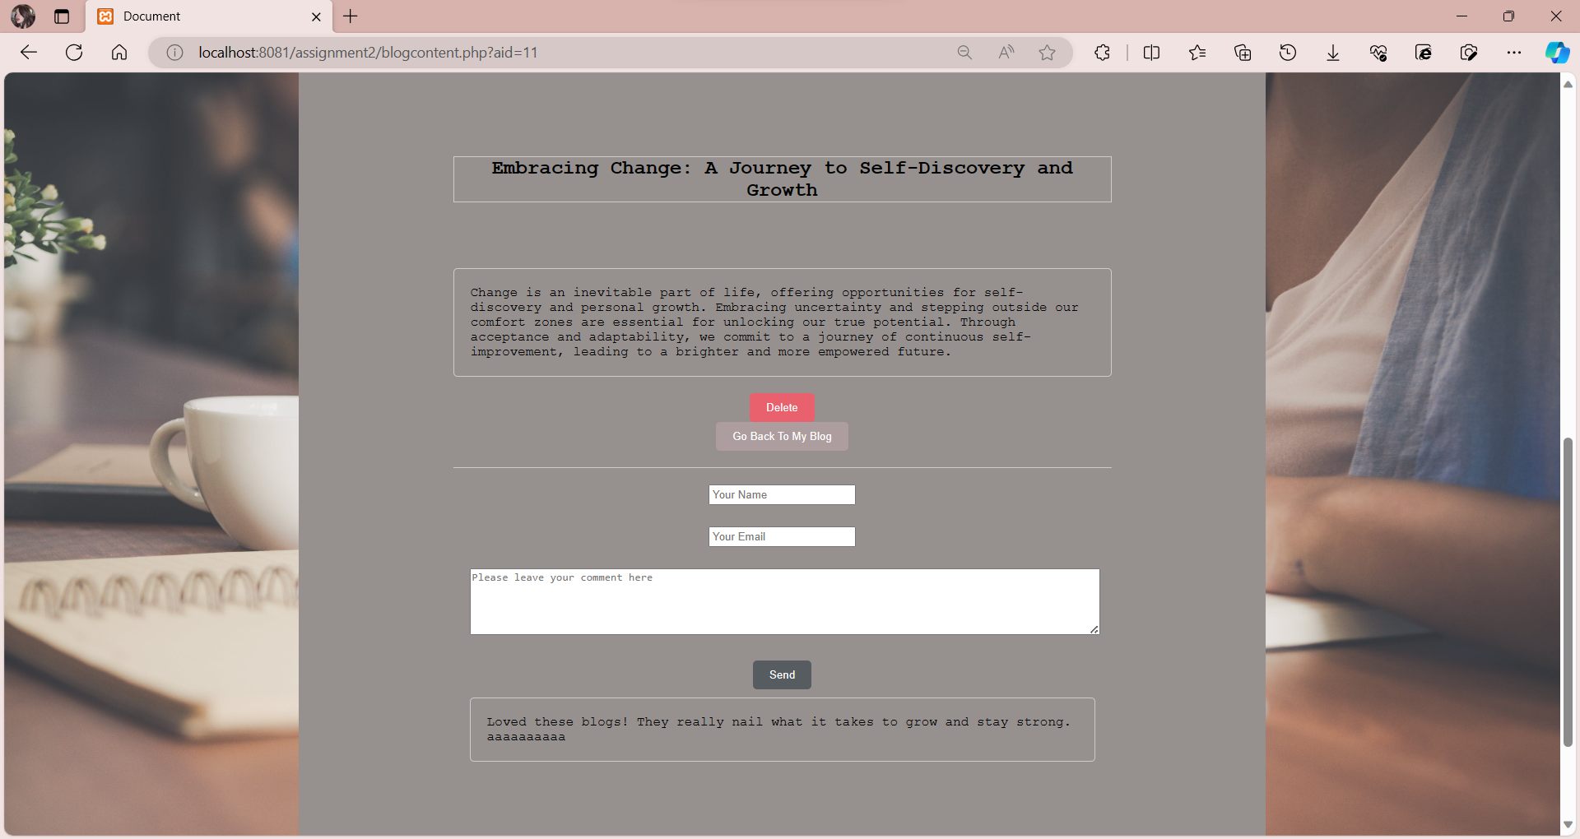

**How to Use BlueBlog**

**1.Creating an Account:**

Visit the "Sign Up & Log In" page to create a new account.

**2.Logging In:**

If you already have an account, log in using the same page.

**3.My Blog:**

Access your personalized space to view and manage your published blog posts.

**4.New Post:**

Navigate to the "New Post" page to write and publish new blog content.

**5.Search and Explore:**

Use the "Search" page to find blog posts from other users.

**6.Viewing Search Results:**

Explore the "Search Results" page to see relevant posts based on your searches.

**7.Reading and Commenting:**

Click on a blog post to access the "Blog Content" page, where you can read the full content and leave your comments.

**Enjoy using BlueBlog and happy blogging!**